Author: Allen Myers

Project: CIS021-HW Lab2

Date: January 31st, 2019

Module: CIS021-Homework 2

Purpose: Convert a logic diagram to an output expression.  
Create truth tables.  
Minimize a circuit.

1. **Examine the following circuit diagram:**

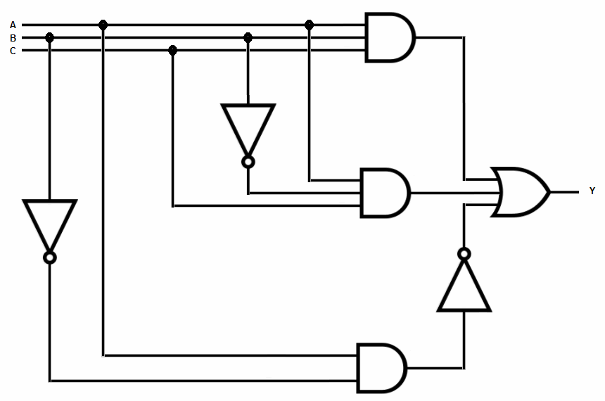

1. **Write the output formula for the diagram:**
2. **Write the truth table for the formula produced in Step 2:**
3. **Reduce the circuit and write the new formula:**